Sangeeth : Summary / Recap and what’s next
- Brief recap.
- Other areas that this could be used for.
  - E.g. assigning tasks to a team. Assigning operations to a multiprocessor core. Etc.
- How/why it can be applied to these areas.
- Conclusion that decomposition is a useful tool at the early planning phase of a new factory.
- Thank you for listening.

Areas that it could be used for
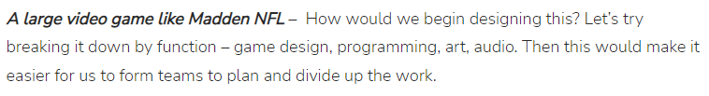

http://steamism.com/technology/decomposition/

- In science, to prove or disprove a hypothesis, you practice decomposition by creating subtasks including background research, observation, generating a hypothesis, determining which variables to test, performing experiments and drawing a conclusion.

https://www.learning.com/blog/why-is-decomposition-required-in-computational-thinking/

A good example of decomposition in computer science can be the merge sort algorithm. In this algorithm, we divide the array into two parts, call itself for the two parts, and then merge the two sorted parts into one.

https://www.geeksforgeeks.org/what-is-decomposition-computational-thinking/

Conclusion that decomposition is a useful tool at the early planning phase of a new factory.

Pros
Saves a lot of time
Establish the big picture: The first step in any new project is to have the main objective, a big picture. Make sure you’re clear about that before continuing with the next steps.
Assess whether further breakdown is necessary
Helps you create a more accurate budget. Estimation

https://monday.com/blog/project-management/decomposition-project-management/#:~:text=Decomposition%20project%20management%20is%20a,product%20into%20smaller%20component%20parts.
Creates more of an accurate plan
Have a better understanding of the impact when there is a change in scope
https://www.easyproject.com/about-us/project-management-made-easy-blog-tips-resources/project-decomposition-why-should-you-do-it

